IT-SIMPLERA INSTITUTE
Cyber Security Analyst Internship Program


WEEK 01 ASSIGNMENT
Cybersecurity Fundamentals & Security Concepts

Prepared By | Ibad Ullah
Program | Cyber Security Analyst Internship
Week | 01
Submission Deadline | 3 July 2026
Supervisor | Senior Cyber Security Analyst
Department | Cyber Security

Introduction
This report has been prepared as part of the Week 01 Assignment for the IT-SIMPLERA Cyber Security Analyst Internship Program. It covers foundational cybersecurity concepts including the CIA Triad, real-world cyberattacks, common security tools, secure network design (with diagram), and the daily responsibilities of a cybersecurity analyst.
Cybersecurity is one of the most critical disciplines in today's digital landscape. As organizations increasingly depend on digital infrastructure, protecting systems, data, and users from malicious actors is paramount. This assignment builds the core knowledge required to become an effective cybersecurity analyst.

Task 1: Five Real-World Cyberattacks
The table below details five major real-world cyberattacks — covering the attack name, year, targeted organization, attack type, technical description, and its impact.

Attack Name | Year | Organization | Type | Description | Impact
WannaCry Ransomware | 2017 | NHS, FedEx, 200,000+ global orgs | Ransomware / Malware | Exploited Windows SMB Eternal Blue vulnerability to self-propagate across networks. Encrypted victim files and demanded Bitcoin ransom. | 200,000+ systems in 150 countries. NHS severely disrupted. Estimated $4B+ in global damages.
Equifax Data Breach | 2017 | Equifax (US Credit Bureau) | Data Breach | Attackers exploited an unpatched Apache Struts CVE. Breach went undetected for 78 days while attackers exfiltrated data silently. | 147 million people's PII stolen (SSNs, birth dates, credit cards). $700M+ in settlements.
SolarWinds Supply Chain | 2020 | SolarWinds / US Federal Agencies / Fortune 500 | Supply Chain APT | Nation-state actors (Russia SVR) injected SUNBURST backdoor into SolarWinds Orion software updates, compromising 18,000+ customers. | US Treasury, DHS, Commerce Department breached. Considered most sophisticated cyberattack in history.
Colonial Pipeline Ransomware | 2021 | Colonial Pipeline Co. (US) | Ransomware (Dark Side) | Dark Side group accessed via compromised VPN password with no MFA. Encrypted IT systems; 100GB data exfiltrated and held for ransom. | Largest US fuel pipeline shut 6 days. East Coast fuel shortages. $4.4M Bitcoin ransom paid.
Yahoo Data Breach | 2013-2014 | Yahoo! Inc. | Data Breach / Nation-State | State-sponsored hackers used spear phishing and cookie forging. All 3 billion accounts (2013) and 500M accounts (2014) compromised; disclosed only in 2016. | Largest data breach in history. Verizon reduced acquisition price by $350M as a result.

Task 2: CIA Triad Violations Analysis
The CIA Triad — Confidentiality, Integrity, and Availability — is the foundation of information security. Below, each attack is mapped to the CIA component(s) it violated, with a detailed explanation of why.

Attack | CIA Component(s) Violated | Explanation
WannaCry (2017) | Availability | Encrypted victim files made systems entirely inaccessible. Hospitals could not access patient records. Availability — ensuring systems are usable when needed — was the primary CIA component violated.
Equifax (2017) | Confidentiality | Private data of 147M people was exfiltrated by unauthorized actors. Confidentiality — protecting sensitive information from unauthorized access — was the core violation.
SolarWinds (2020) | Integrity + Confidentiality | Integrity was violated: legitimate software was tampered with via a malicious update. Confidentiality was also violated as attackers gained covert access to classified communications for months.
Colonial Pipeline (2021) | Availability | Ransomware encryption forced a 6-day pipeline shutdown affecting critical energy infrastructure serving millions. Availability of a national critical system was directly compromised.
Yahoo (2013-14) | Confidentiality + Integrity | Confidentiality was violated by mass data exfiltration of 3B accounts. Integrity was also violated as attackers forged authentication cookies to impersonate users without credentials.

CIA Triad — Definitions
- Confidentiality: Protecting sensitive information from unauthorized access or disclosure.
- Integrity: Ensuring information and systems remain accurate and unaltered by unauthorized parties.
- Availability: Ensuring authorized users can access systems and data reliably when needed.

Task 3: Three Cybersecurity Tools
The following profiles three essential cybersecurity tools used daily by security professionals, covering each tool's purpose, function, and real-world use case.

1. Wireshark
Purpose | Network Traffic Analyzer / Packet Sniffer
Function | Captures and decodes network packets in real-time across 700+ protocols. Allows analysts to inspect every layer of network communication from Ethernet frames to application-layer HTTP/HTTPS traffic.
Use Case | Detecting suspicious traffic patterns (unusual DNS queries, unencrypted credentials, C2 beaconing), forensic analysis after incidents, validating encryption is working, and troubleshooting network connectivity issues.

2. Nmap (Network Mapper)
Purpose | Network Discovery & Security Auditing
Function | Sends crafted packets to discover active hosts, open ports, running services, OS versions, and known vulnerabilities. Supports Nmap Scripting Engine (NSE) for automated vulnerability detection and service enumeration.
Use Case | Network audits to map all devices and open ports, identifying unauthorized/rogue devices, assessing the attack surface, verifying firewall rules, and performing pre-penetration test reconnaissance.

3. Metasploit Framework
Purpose | Penetration Testing & Exploit Development
Function | Open-source framework with a library of 2,000+ known exploits, payloads, and auxiliary modules. Enables security professionals to simulate real-world attacks in authorized engagements to identify and remediate vulnerabilities proactively.
Use Case | Authorized penetration testing to validate security controls, verifying that patches correctly remediated CVEs, security awareness training demonstrations, and red team operations within a defined scope.

Task 4: Secure Home Network Design
A secure home network requires multiple layers of defense (defense-in-depth) to protect all connected devices from external threats and limit damage if any single layer is breached. The network is segmented using VLANs to isolate device categories from each other.

Network Diagram
The diagram below illustrates the complete secure home network architecture, from the ISP/Internet entry point through the modem, router/firewall, switch, and three isolated VLAN zones for Work, Personal, and IoT/Guest devices.

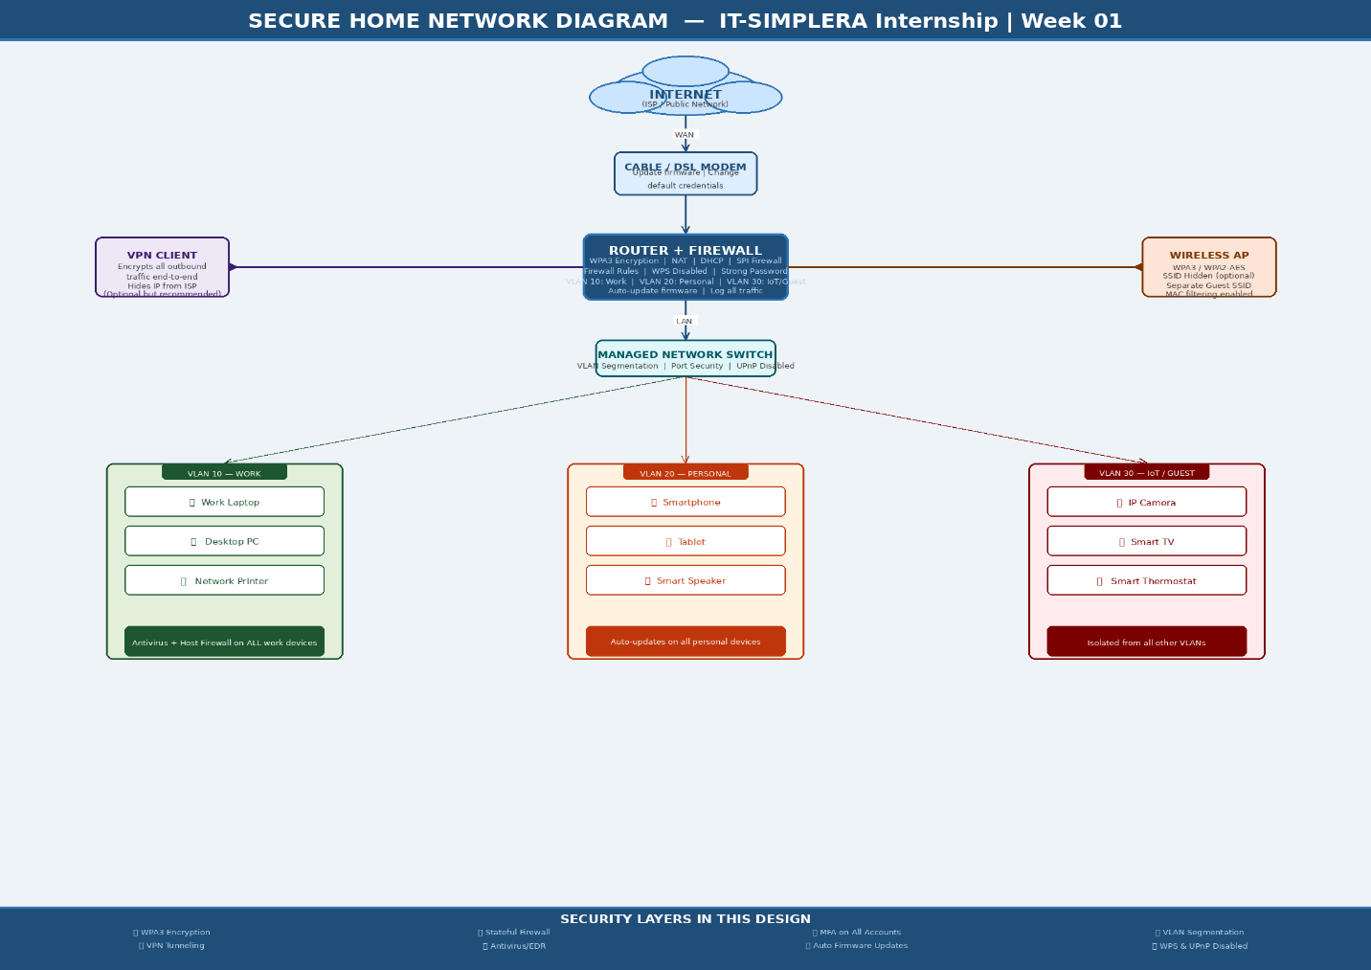
Figure 1: Secure Home Network Architecture — IT-SIMPLERA Week 01

Network Architecture — Layer by Layer
Layer | Component | Security Role & Configuration
1 | Internet (ISP) | Entry point — all traffic from/to the internet. ISP only sees the router's public IP address.
2 | Cable/DSL Modem | Converts ISP signal to digital data. Change default admin credentials immediately. Keep firmware updated.
3 | Router + SPI Firewall | Core security device. Enforces stateful packet inspection, NAT, DHCP. Enable WPA3, disable WPS, use a strong passphrase. Log all traffic. VLAN-aware.
4 | VPN Client (Optional) | Encrypts all outbound traffic end-to-end, masking activity from the ISP and external surveillance. Strongly recommended for remote work.
5 | Wireless AP | WPA3 or WPA2-AES encryption. Strong unique SSID password. SSID hidden (optional). Separate guest SSID. MAC address filtering.
6 | Managed Switch | Provides VLAN segmentation across three isolated zones. Disables UPnP and unused ports. Enables port security to prevent unauthorized device connections.
7 | VLAN 10 — Work | Work laptops, desktop PCs, network printer. All devices require antivirus/EDR software and host-based firewall. MFA enforced on all accounts.
8 | VLAN 20 — Personal | Smartphones, tablets, smart speakers. Auto-updates enabled. Separate from work VLAN to prevent lateral movement between zones.
9 | VLAN 30 — IoT/Guest | IP cameras, smart TV, thermostat, guest devices. Fully isolated from VLAN 10 and 20. Default credentials changed on all IoT devices. Firmware auto-updated.

Security Best Practices Applied
- WPA3 encryption for all Wi-Fi connections (WPA2-AES as minimum fallback)
- Change all default credentials on router, modem, and IoT devices immediately
- Enable automatic firmware updates on all network equipment and end devices
- VLAN segmentation to isolate Work, Personal, and IoT/Guest traffic
- Antivirus/EDR software deployed on all computing devices in VLAN 10 and 20
- Multi-Factor Authentication (MFA) enforced on all critical accounts
- VPN for encrypted communications, especially for remote work scenarios
- Disable unused network services: WPS, UPnP, Telnet, remote management
- Regular audits of connected devices to detect unauthorized/rogue connections
- Separate guest SSID with bandwidth throttling and no access to main VLANs

Task 5: What Does a Cybersecurity Analyst Do Every Day?
A cybersecurity analyst is the frontline defender of an organization's digital assets, systems, and data. The role blends proactive threat hunting, reactive incident response, continuous monitoring, and cross-functional collaboration. No two days are identical, but core activities define the rhythm of the work.

Morning: Threat Intelligence Review & Alert Triage
The analyst begins by reviewing overnight alerts generated by the SIEM (Security Information and Event Management) system — a platform that aggregates and correlates logs from across the network, endpoints, and cloud services. They assess threat intelligence feeds for newly discovered CVEs, active ransomware campaigns, or phishing waves targeting their industry. High-severity alerts are immediately escalated for investigation, while low-priority findings are logged and queued for later review.

Mid-Morning: Active Monitoring & Incident Response
Continuous monitoring of security dashboards flags anomalies such as unusual login patterns (geographic impossibility), abnormal data transfers, privilege escalation attempts, or lateral movement across internal systems. When a potential incident is detected, the analyst follows the Incident Response lifecycle: Identify → Contain → Eradicate → Recover → Lessons Learned. This may involve isolating compromised endpoints, blocking malicious IP addresses, resetting compromised credentials, and preserving forensic evidence.

Afternoon: Vulnerability Management & Security Audits
Analysts run vulnerability scans (Nessus, Qualys, OpenVAS) to identify unpatched systems, misconfigured services, or exposed sensitive ports. Findings are risk-scored using CVSS and prioritized for patching in collaboration with the IT team. They may run phishing simulations to measure employee awareness, review and tighten firewall access control lists, and audit user account permissions to enforce the principle of least privilege — ensuring no user has more access than their role requires.

End of Day: Documentation, Reporting & Knowledge Sharing
Every finding, alert, and action must be documented thoroughly in the ticketing system and incident logs. Analysts prepare daily or weekly security status reports for management, update runbooks and playbooks with lessons learned, and contribute to security awareness training content. They may also conduct proactive threat hunting — using indicators of compromise (IoCs) and threat intelligence to search for attacker activity that automated tools may have missed.

Ongoing Core Responsibilities
- Staying current with the latest CVEs, zero-days, and threat actor TTPs (Tactics, Techniques & Procedures)
- Tuning SIEM detection rules to reduce false positives and improve signal quality
- Collaborating with DevOps/development teams on secure coding and DevSecOps practices
- Participating in tabletop exercises and red team/blue team drills to test IR readiness
- Maintaining security tools (AV signatures, IDS/IPS rules, firewall policies)
- Pursuing continuous professional development: CEH, Security+, CISSP, OSCP certifications
In summary, a cybersecurity analyst is a vigilant, analytical professional who combines deep technical knowledge with clear communication skills — detecting threats before they cause harm, and responding decisively when they do. The role demands constant learning and an inherently proactive mindset.

Challenges Encountered
- Distinguishing CIA Triad violations was nuanced — many attacks violate multiple components simultaneously. Careful analysis of each attack vector helped identify primary vs secondary violations.
- Verifying accurate impact figures for older breaches (Yahoo, Equifax) required cross-referencing multiple authoritative sources including SEC filings, FTC press releases, and academic papers.
- Designing the secure home network required balancing strong security with practical usability — overly restrictive controls can impede productivity, so a layered VLAN-based approach was adopted.
- Creating the network diagram required careful layout planning to clearly show all seven layers without visual clutter, while ensuring each security control was labeled clearly.

Conclusion
This Week 01 assignment has provided a comprehensive foundation in cybersecurity fundamentals. Researching real-world attacks makes clear that the consequences of security failures are severe — impacting organizations financially, operationally, and reputationally, while exposing millions of individuals to identity theft and fraud.
The CIA Triad provides an elegant and universally applicable framework for categorizing security incidents and guiding security program design. The three tools profiled — Wireshark, Nmap, and Metasploit — represent core capabilities that any competent security analyst must understand and be able to deploy responsibly.
The secure home network design, with its defense-in-depth approach and VLAN segmentation, demonstrates that security is not a single product but a disciplined, multi-layered strategy. Finally, the analyst daily responsibilities overview reveals that this profession demands constant vigilance, proactive thinking, and continuous learning — making it one of the most challenging and rewarding fields in technology.

